MakeArrays results

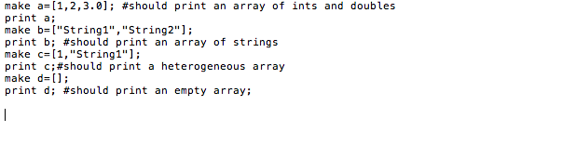

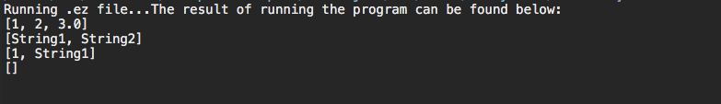

ManipulateArray results

